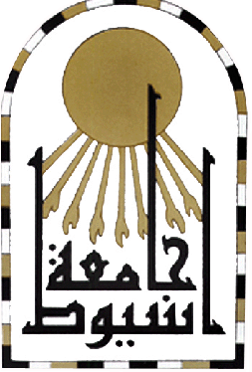
Assiut university
Faculty of Medicine

c.v

Name: Dr/walid saad ElDien Mohamed Ibrahim.
Place of Work: Department of Ophthalmology, Faculty of Medicine- Assiut University.
Date of Birth: 05/08/1972. Place of Birth: Libya
Current Job: Lecturer.
Religion: Muslim. Nationality: Egyptian

Qualifications:
- M.B.B.Ch in Medicine and Surgery- September 1995, with a general grade of "Very Good" With Honor's Assiut University.
- Master's Degree in Ophthalmology- November 26th 2000, with a general grade of "Good" Assiut University.
- Ph.D. Degree in Ophthalmology, 2008 Assiut University.

Specialization: Ophthalmology.
Positions Held:
- House officer, Assiut University Hospital, form 01/03/1996.
- Resident physician, Department of Ophthalmology, Assiut University Hospital, from 08/03/1997.
- Demonstrator, Department of Ophthalmology, faculty of Medicine, Assiut University, from18/04/2001.
- Assistant Lecturer, Department of Ophthalmology, Faculty of Medicine, Assiut University, from 06/06/2001.
- Lecturer, Department of Ophthalmology, Faculty of Medicine, Assiut University, from 28/12/2008.
- Member of European society of cataract and refractive surgery.
- Member of European society of Retina surgeons 2009
- Member of European society of Academy of ophthalmology since 2010.
Marital Status: Married with children.
Military Service: Done.

